# TASK NO.1

Write a query to order employee first name in Descending Order.

# QUERY

select FirstName from Employees order by FirstName desc

# OUTPTUT

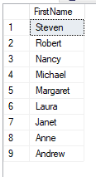

# TASK NO.2

Display the highest, lowest, sum and average UnitPrice of each Category. Label

column as CategoryId, Maximum, Minimum, Sum and Average, respectively.

Round your results to the nearest whole number. (Table: Products)

# QUERY

select round(sum(UnitPrice),0) as sumOfprice,round(AVG(UnitPrice),0) as avgOfprice,round(max(UnitPrice),0) as maxOfprice,round(min(UnitPrice),0) as minOfprice from Products

# OUTPTUT



# TASK NO.3

Display the highest, lowest, sum and average UnitPrice of each Category, where

highest UnitPrice lies in the range of 50$ to 100$. Label column as CategoryId,

Maximum, Minimum, Sum and Average, respectively. (Table: Products)

# QUERY

select sum(UnitPrice)as sumOfprice,avg(UnitPrice)as avgOfprice,min(UnitPrice)as minOfprice,max(UnitPrice) as maxOfprice from Products group by productname having max(UnitPrice) between 50 and 100

# OUTPTUT

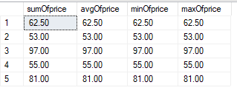

# TASK NO.4

From customers table, Count all customers is each region where region is not

null. (Table: Customers)

# QUERY

select count(CustomerID)as customID,Region from Customers group by Region having Region is not null

# OUTPTUT

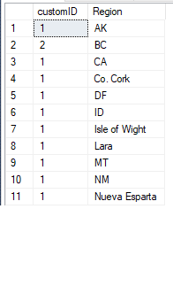

# TASK NO.5

Write a query to display the number of ContactName with same ContactTitle.

Sort contact title in descending order. (Table: Customers)

# QUERY

select ContactName,ContactTitle from Customers order by ContactTitle desc

# OUTPTUT

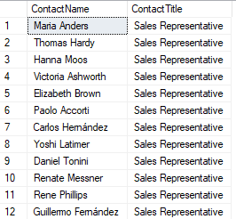

# TASK NO.6

Write a query that count all orders against each product id. No of orders should be greater than 50. (Table: [Order Details])

# QUERY

select count(Quantity)as Orderzz,ProductID from [Order Details] group by ProductID having count(Quantity) > 50

# OUTPTUT

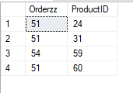

# TASK NO.7

How many people are in each unique city in the employee table that have more than one person in the city? Select the city and display the number of how many people are in each if it’s greater than 1.(Table: Employees

# QUERY

select distinct city,count(FirstName)as Person from Employees group by City having count(FirstName) > 1

# OUTPTUT

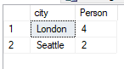

# TASK NO.8

List only those cities in which more than or equals to 2 employees are living.

# QUERY

select city,count(FirstName)as Person from Employees group by City having count(FirstName) >= 2

# OUTPTUT



# TASK NO.9

From the [Order Details] table, select the Product’s id , maximum price and minimum price for each specific product in the table, sort the list by product id in ascending order.

# QUERY

select ProductID , max(UnitPrice) as maxPrice,min(UnitPrice) as minPrice from [Order Details] group by ProductID order by ProductID asc

# OUTPTUT

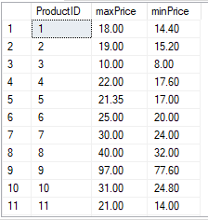

# TASK NO.10

Retrieve the number of employees in each city in which there are at least 2 employees.

# TASK NO.11

Find the product name, maximum price and minimum price of each product having maximum price greater than 20.00 $. Order by maximum price.

# QUERY

select ProductName,max(UnitPrice)as maxPrice,min(UnitPrice) as minPrice from Products group by ProductName having max(UnitPrice) > 20

# OUTPTUT

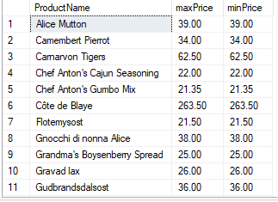

# TASKNO.12

Find the number of sales representatives in each city that contains at least 2 sales representatives. Order by the number of employees.

# QUERY

select count(Title) as no_ofemployee,City,Title from Employees group by City,Title having Title='sales representative' and count(Title)>2

# OUTPUT



# TASKNO.13

From customers table, Count all customers in each region whose contactname contains manager and region is not null. (Table: Customers)

# QUERY

select count(contactname),contactTitle,region from customers group by region,ContactTitle having region is not null and contactTitle like '%manager%'

# OUTPUT

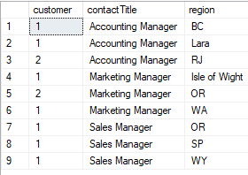

# TASKNO.14

Write a query to list no of customers with same ContactTitle if No of customers is greater than 5. However their ContactTitle does not contain Manager. Order by contact title in Descending order(Table: Customers)

# QUERY

select count(ContactName) as customer ,ContactTitle from customers group by ContactTitle having count(ContactName) > 5 and contactTitle not like '%manager%' order by ContactTitle desc

# OUTPUT

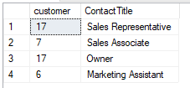

# TASKNO.17

Give an example to show that COUNT(*) can be combined with other aggregate functions in the select list.

# QUERY

select count(*) as No_ofRows,sum(UnitPrice)as sumOfprice,avg(UnitPrice)as avgOfprice from Products

# OUTPUT

